NAME: ___________________________________________________ CHECK/CASH TOTAL: ____________ CHECK # ___________

(make checks out to BHS TRACK)

|  |  |  |  |  |  |  |  |  |  |  |
| --- | --- | --- | --- | --- | --- | --- | --- | --- | --- | --- |
| **Clothing Options** | | YL/ XS | S | M | L | XL | 2XL | 3XL | PRICE | TOTAL |
| **Girl's Red Spandex** --UNIFORM (Uniform: Mandatory for ALL Relay Runners) | |  |  |  |  |  |  |  | $20.00 |  |
| **Boy's R/W Compression Short** --UNIFORM (Mandatory for ALL non-throwing events) | |  |  |  |  |  |  |  | $20.00 |  |
| **Team Jacket** --UNIFORM (Men's & Women's Cut) | |  |  |  |  |  |  |  | $60.00 |  |
|  | **Grand Total =** | | | | | | | | |  |

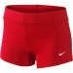

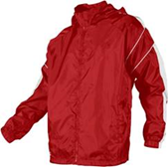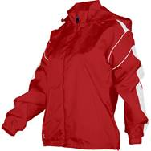Girl’s Spandex Short Team Jacket Women’s & Men’s Cut—first or last name wanted on chest: __________________________

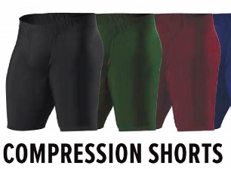Boy’s Compression Short **BLACK**

NAME: ___________________________________________________ CHECK/CASH TOTAL: ____________ CHECK # ___________

(make checks out to BHS TRACK)

|  |  |  |  |  |  |  |  |  |  |  |
| --- | --- | --- | --- | --- | --- | --- | --- | --- | --- | --- |
| **Clothing Options** | | YL/ XS | S | M | L | XL | 2XL | 3XL | PRICE | TOTAL |
| **Girl's Red Spandex** --UNIFORM (Uniform: Mandatory for ALL Relay Runners) | |  |  |  |  |  |  |  | $20.00 |  |
| **Boy's R/W Compression Short** --UNIFORM (Mandatory for ALL non-throwing events) | |  |  |  |  |  |  |  | $20.00 |  |
| **Team Jacket** --UNIFORM (Men's & Women's Cut) | |  |  |  |  |  |  |  | $60.00 |  |
|  | **Grand Total=** | | | | | | | | |  |



Girl’s Spandex Short Team Jacket Women’s & Men’s Cut—first or last name wanted on chest: __________________________



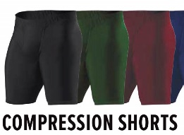Boy’s Compression Short **BLACK**